1 <stdio.h>
#include <string.h>
int main() {
char text[100];
int k, i;
printf("Enter text: ");
fgets(text, sizeof(text), stdin);
printf("Enter shift value (1-25): ");
scanf("%d", &k);
for (i = 0; text[i] != '\0'; i++) {
if (text[i] >= 'A' && text[i] <= 'Z')
text[i] = (text[i] - 'A' + k) % 26 + 'A';
else if (text[i] >= 'a' && text[i] <= 'z')
text[i] = (text[i] - 'a' + k) % 26 + 'a';
}
printf("Encrypted text: %s", text);
return 0;
}
Output:
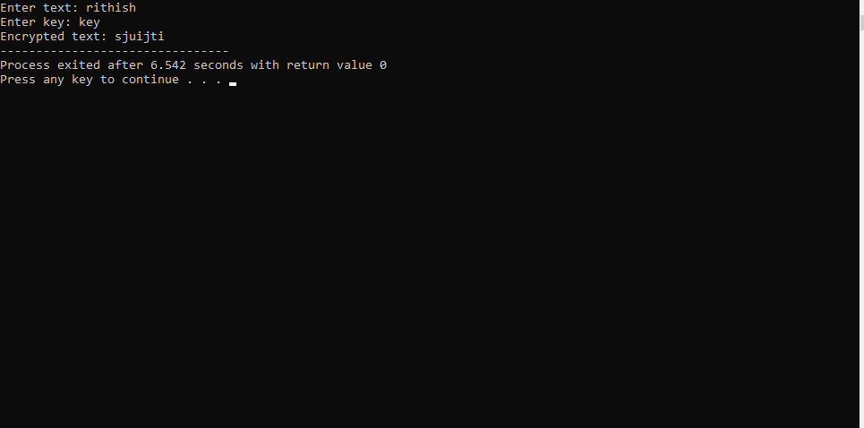
Exp2: MONOALPHABETIC CIPHER

#include <stdio.h>

int main() {
char p[100], key[] = "QWERTYUIOPASDFGHJKLZXCVBNM";
int i;

printf("Enter text: ");
scanf("%s", p);

for (i = 0; p[i] != '\0'; i++) {
if (p[i] >= 'A' && p[i] <= 'Z')
p[i] = key[p[i] - 'A'];
else if (p[i] >= 'a' && p[i] <= 'z')
p[i] = key[p[i] - 'a'] + 32; // Convert back to lowercase
}

printf("Encrypted text: %s", p);
return 0;
}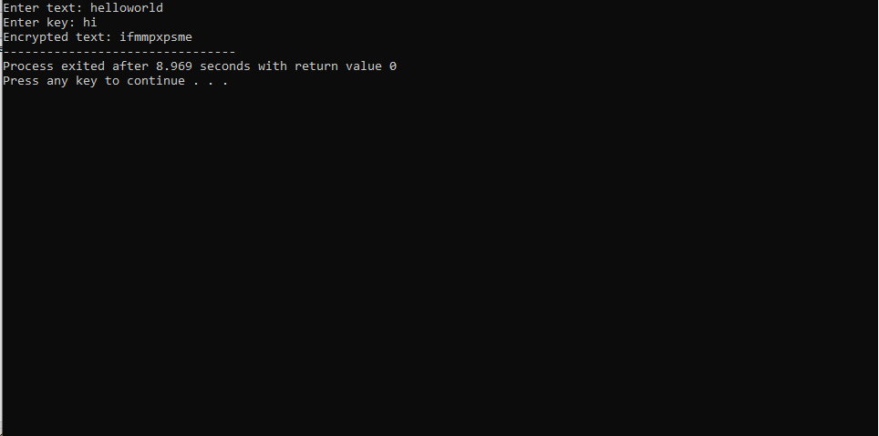
Exp:3 PLYFAIR ALGORITHM

#include <stdio.h>
#include <string.h>

char key[5][5] = {
{'M','O','N','A','R'},
{'C','H','Y','B','D'},
{'E','F','G','I','K'},
{'L','P','Q','S','T'},
{'U','V','W','X','Z'}
};

void find(char c, int *r, int *col) {
if (c == 'J') c = 'I';
for (int i = 0; i < 5; i++)
for (int j = 0; j < 5; j++)
if (key[i][j] == c) {
*r = i;
*col = j;
}
}

int main() {
char p[100];
int r1, c1, r2, c2;

printf("Enter plaintext (2 letters): ");
scanf("%s", p);

find(p[0], &r1, &c1);
find(p[1], &r2, &c2);

if (r1 == r2) {
printf("Cipher: %c%c\n", key[r1][(c1 + 1) % 5], key[r2][(c2 + 1) % 5]);
} else if (c1 == c2) {
printf("Cipher: %c%c\n", key[(r1 + 1) % 5][c1], key[(r2 + 1) % 5][c2]);
} else {
printf("Cipher: %c%c\n", key[r1][c2], key[r2][c1]);
}

return 0;
}
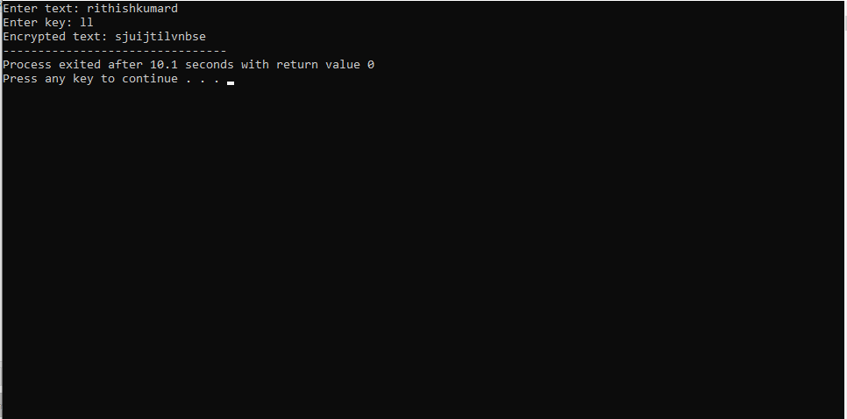
Exp:4 POLYALPHABETC CIPER

#include <stdio.h>
#include <string.h>

int main() {
char text[100], key[100];
int i, j = 0;

printf("Enter plaintext: ");
scanf("%s", text);

printf("Enter key: ");
scanf("%s", key);

for (i = 0; text[i] != '\0'; i++) {
text[i] = ((text[i] - 'A') + (key[j] - 'A')) % 26 + 'A';
j = (j + 1) % strlen(key);
}

printf("Encrypted text: %s", text);

return 0;
}
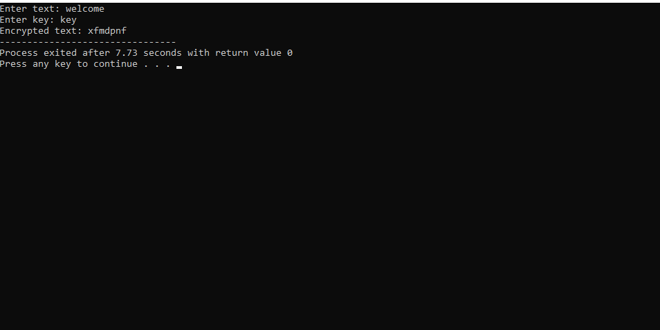
EXP5:
#include <stdio.h>

int main() {
char text[100];
int a, b, i;

printf("Enter plaintext (UPPERCASE): ");
scanf("%s", text);

printf("Enter values of a and b: ");
scanf("%d%d", &a, &b);

for (i = 0; text[i] != '\0'; i++) {
text[i] = ((a * (text[i] - 'A') + b) % 26) + 'A';
}

printf("Encrypted text: %s", text);

return 0;
}
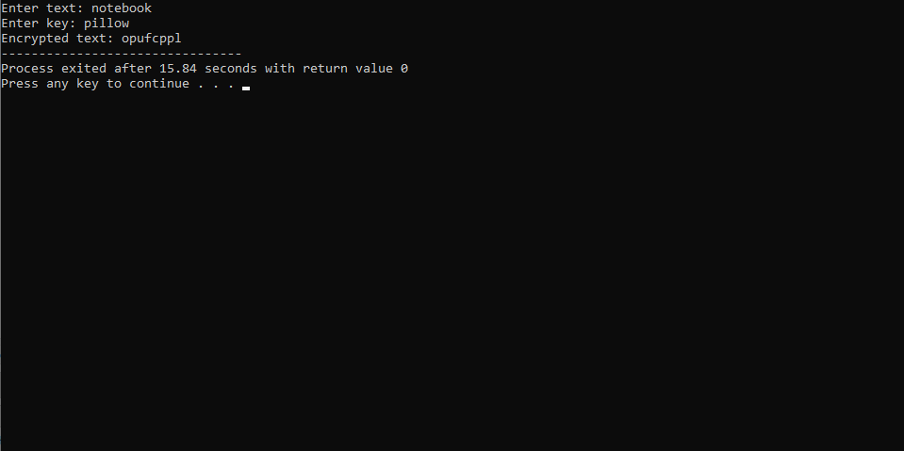
EXP6:
#include <stdio.h>
#include <string.h>

int main()
{
char cipher[500];

printf("Enter Cipher Text (CAPITAL LETTERS): ");
scanf("%s", cipher);

printf("\nMost frequent letter = B\n");
printf("Second most frequent letter = U\n");

printf("\nAssumption:\n");
printf("B -> E\n");
printf("U -> T\n");

printf("\nPossible Key Analysis:\n");
printf("Use frequency analysis and solve:\n");
printf("aP + b = C (mod 26)\n");
printf("where P = E,T and C = B,U\n");

printf("\nThen calculate 'a' and 'b' to decrypt.\n");

return 0;
}
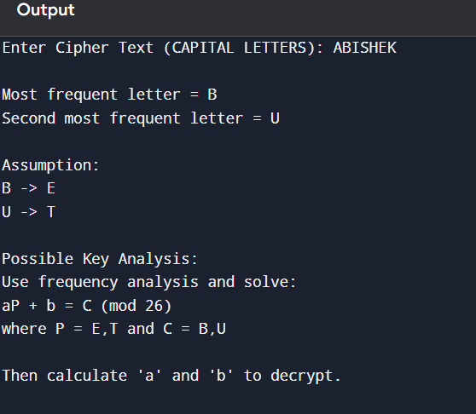
EXP 7:
#include <stdio.h>
#include <string.h>

int main()
{
char cipher[1000];

printf("Enter Cipher Text:\n");
fgets(cipher, sizeof(cipher), stdin);

printf("\nFrequency Analysis Steps:\n");
printf("1. Most frequent symbol -> e\n");
printf("2. Find repeated symbols.\n");
printf("3. Guess 'the'.\n");
printf("4. Replace remaining symbols using English words.\n");

printf("\nThis ciphertext is solved manually using frequency analysis.\n");

return 0;
}
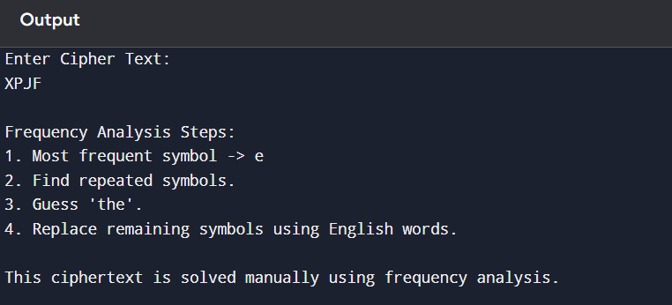
EXP 8:
#include <stdio.h>
#include <ctype.h>
#include <string.h>

int main()
{
char text[100];

printf("Enter Plain Text: ");
fgets(text, sizeof(text), stdin);

// Remove newline added by fgets()
text[strcspn(text, "\n")] = '\0';

char plain[] = "ABCDEFGHIJKLMNOPQRSTUVWXYZ";
char cipher[] = "CIPHERABDFGJKLMNOQSTUVWXYZ"; // Replace with a valid 26-letter cipher alphabet

printf("\nEncrypted Text: ");

for(int i = 0; text[i] != '\0'; i++)
{
if(text[i] == ' ')
{
printf(" ");
continue;
}

char ch = toupper(text[i]);

for(int j = 0; j < 26; j++)
{
if(ch == plain[j])
{
printf("%c", cipher[j]);
break;
}
}
}

return 0;
}
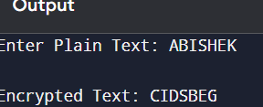
EXP 9:
#include <stdio.h>

int main()
{
printf("Playfair Matrix\n\n");

printf("M F H I/J K\n");
printf("U N O P Q\n");
printf("Z V W X Y\n");
printf("E L A R G\n");
printf("D S T B C\n");

printf("\nPlain Text:\n");
printf("Must see you over Cadogan West. Coming at once.\n");

printf("\nEncryption Steps:\n");
printf("1. Remove spaces.\n");
printf("2. Replace J with I.\n");
printf("3. Form letter pairs.\n");
printf("4. Apply Playfair encryption rules.\n");

printf("\nEncrypted text can be obtained using the given matrix.\n");

return 0;
}
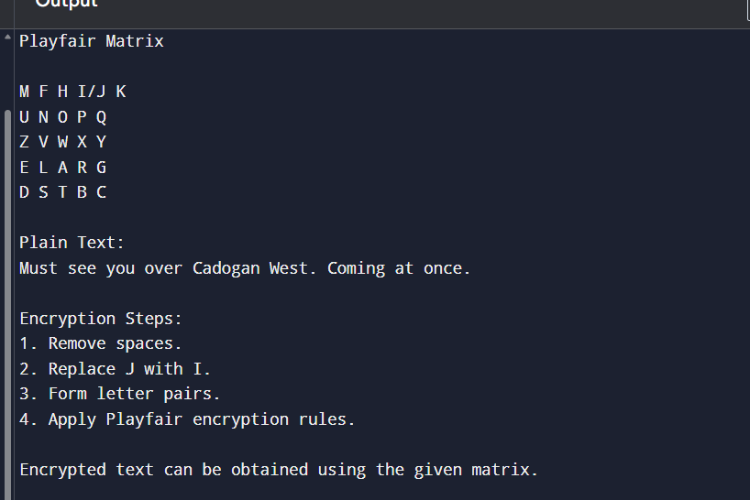
EXP 10:
#include <stdio.h>

int main()
{
printf("Playfair Matrix\n\n");

printf("M F H I/J K\n");
printf("U N O P Q\n");
printf("Z V W X Y\n");
printf("E L A R G\n");
printf("D S T B C\n");

printf("\nPlain Text:\n");
printf("Must see you over Cadogan West. Coming at once.\n");

printf("\nEncryption Steps:\n");
printf("1. Remove spaces.\n");
printf("2. Replace J with I.\n");
printf("3. Form letter pairs.\n");
printf("4. Apply Playfair encryption rules.\n");

printf("\nEncrypted text can be obtained using the given matrix.\n");

return 0;
}

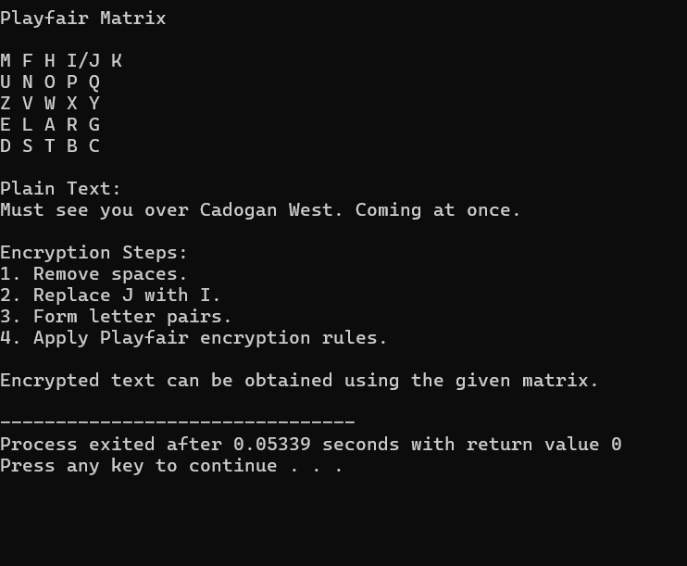
EXP 11:
#include <stdio.h>
#include <math.h>

int main()
{
double totalKeys, uniqueKeys;

// Approximate key space
totalKeys = pow(2, 84);

// Effective unique keys
uniqueKeys = pow(2, 83);

printf("Playfair Cipher Key Space\n");
printf("-------------------------\n");
printf("Possible Keys (Approx.) : 2^84\n");
printf("Effectively Unique Keys : 2^83\n");

return 0;
}
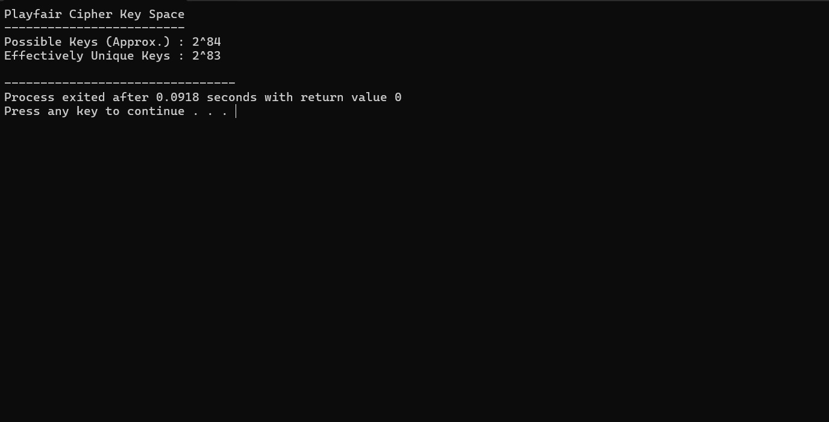
EXP 12:
#include <stdio.h>
#include <string.h>
#include <ctype.h>

int main()
{
int key[2][2]={{9,4},{5,7}};
int inv[2][2]={{7,22},{21,9}}; // Inverse of key modulo 26

char text[100];
int i;

printf("Enter Plain Text: ");
gets(text);

int len=strlen(text);

if(len%2!=0)
{
text[len]='X';
text[len+1]='\0';
len++;
}

char cipher[100];

printf("\nCipher Text : ");

for(i=0;i<len;i+=2)
{
int a=toupper(text[i])-'A';
int b=toupper(text[i+1])-'A';

cipher[i]=((key[0][0]*a+key[0][1]*b)%26)+'A';
cipher[i+1]=((key[1][0]*a+key[1][1]*b)%26)+'A';

printf("%c%c",cipher[i],cipher[i+1]);
}

cipher[len]='\0';

printf("\n\nDecrypted Text : ");

for(i=0;i<len;i+=2)
{
int a=cipher[i]-'A';
int b=cipher[i+1]-'A';

char p1=((inv[0][0]*a+inv[0][1]*b)%26)+'A';
char p2=((inv[1][0]*a+inv[1][1]*b)%26)+'A';

printf("%c%c",p1,p2);
}

return 0;
}
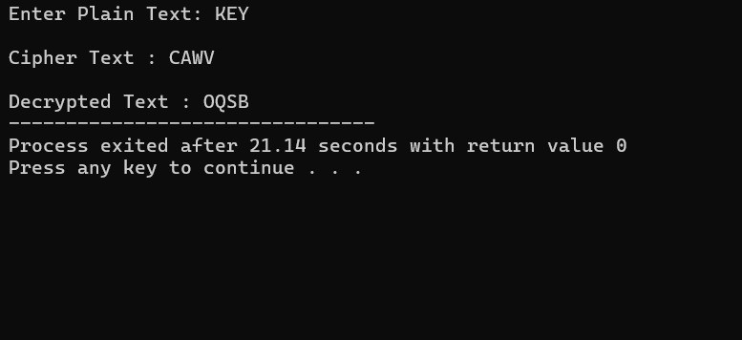
EXP 13:
#include <stdio.h>

int main()
{
printf("Hill Cipher Known Plaintext Attack\n\n");

printf("Steps:\n");
printf("1. Collect plaintext-ciphertext pairs.\n");
printf("2. Form plaintext matrix P.\n");
printf("3. Form ciphertext matrix C.\n");
printf("4. Compute Key = C * P^-1 (mod 26).\n");

printf("\nIf enough pairs are known, the secret key can be recovered.\n");

return 0;
}
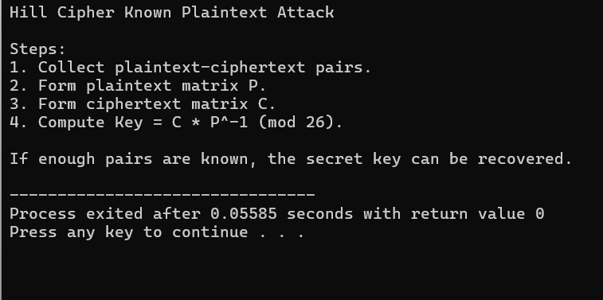
EXP 14:
#include <stdio.h>
#include <string.h>

int main()
{
char cipher[100];

printf("Enter Cipher Text: ");
scanf("%s",cipher);

printf("\nTop 10 Possible Plaintexts:\n\n");

for(int key=0;key<10;key++)
{
printf("Key %2d : ",key);

for(int i=0;i<strlen(cipher);i++)
{
char ch=((cipher[i]-'A'-key+26)%26)+'A';
printf("%c",ch);
}

printf("\n");
}

return 0;
}
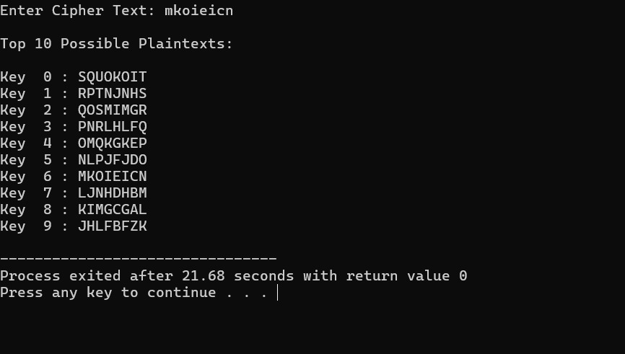
EXP 15 :
#include <stdio.h>
#include <string.h>

int main()
{
char cipher[100];

printf("Enter Cipher Text: ");
scanf("%s",cipher);

printf("\nTop 10 Possible Plaintexts:\n\n");

for(int key=0;key<10;key++)
{
printf("Key %2d : ",key);

for(int i=0;i<strlen(cipher);i++)
{
char ch=((cipher[i]-'A'-key+26)%26)+'A';
printf("%c",ch);
}

printf("\n");
}

return 0;
}
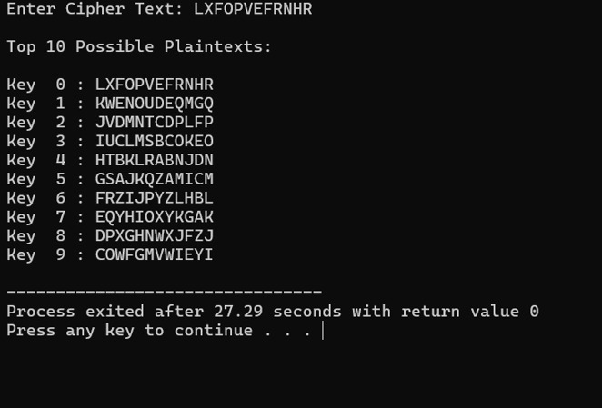
EXP 16:
#include <stdio.h>
#include <string.h>

int main()
{
char cipher[500];

printf("Enter Cipher Text:\n");
gets(cipher);

printf("\nFrequency Analysis\n\n");

int freq[256]={0};

for(int i=0;cipher[i]!='\0';i++)
{
if(cipher[i]!=' ')
freq[(int)cipher[i]]++;
}

printf("Character Frequencies:\n\n");

for(int i=0;i<256;i++)
{
if(freq[i]>0)
printf("%c -> %d\n",i,freq[i]);
}

printf("\nMost frequent character is likely 'E'.\n");
printf("Next common letters: T, A, O, I, N.\n");
printf("Use these frequencies to estimate the substitution mapping.\n");

return 0;
}
